
San Francisco Bay University

CE450 Fundamentals of Embedded Engineering
Lab 4 Buzzer Control

Objectives:
In this lab, students will learn how to control on-board buzzer in Python program on Raspberry Pi board and do hands-on exercise through lab assignments.

Introduction:
One buzzer is available in Sunfounder accessory box. If a control signal generated from one of pins in GPIO port is logic low, it will switch buzzer on through a BJT, otherwise, off.

Equipment:
The equipment you require is as follows:
- Laptop & Raspberry Pi 3 model Board
- SunFounder Super Starter Kit V2.0 for Raspberry Pi

The Laboratory Procedure:
- Hardware connection
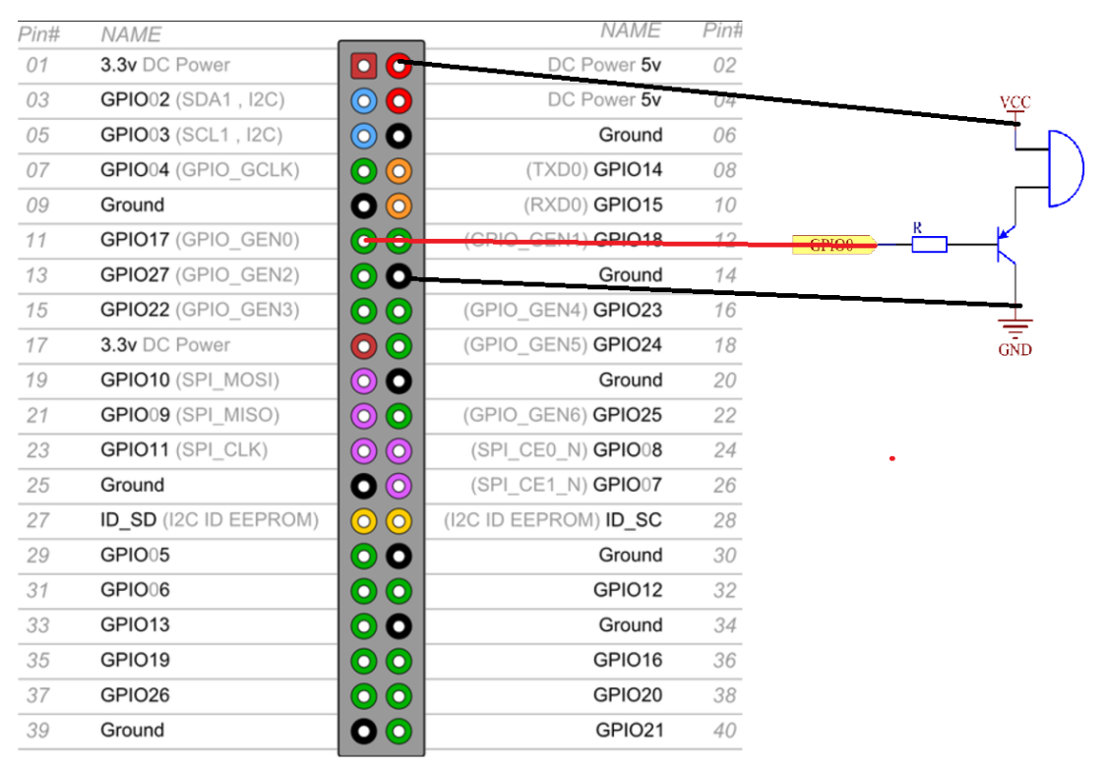
- Control program in Python

# Python program
import RPi.GPIO as GPIO
import time

BeepPin = 11 # pin11

def setup():
GPIO.setmode(GPIO.BOARD) # Numbers GPIOs by physical location
GPIO.setup(BeepPin, GPIO.OUT) # Set BeepPin's mode is output
GPIO.output(BeepPin, GPIO.HIGH) # Set BeepPin high(+3.3V) to off beep

def loop():
while True:
GPIO.output(BeepPin, GPIO.LOW) # Switch on Buzzer
time.sleep(0.1) # 0.1s delay
GPIO.output(BeepPin, GPIO.HIGH)
time.sleep(0.1)

def destroy():
GPIO.output(BeepPin, GPIO.HIGH) # beep off
GPIO.cleanup() # Release resource

print 'Press Ctrl+C to end the program...'

setup()
try:
loop()
except KeyboardInterrupt: # When 'Ctrl+C' is pressed, the child program destroy() will be executed.
destroy()

*Note: Hardware connection reference and running command
https://learn.sunfounder.com/lesson-6-buzzer/ https://learn.sunfounder.com/category/super-kit-v3-0-for-raspberry-pi/

The Laboratory Assignments:

- Implement the buzzer control based on the above example program.

- Add one LED to the buzzer control circuit to make it on when the buzzer is ringing and off if the buzzer is silent.

